Annexure to Advisory no.05/2022 dated 11.02.2022 on Suo-motu creation of Challan by Tax officers for payment of arrears of revenue realized through recovery actions.

Step 1: Click “Menu” > CE or ST > ”E-Payment” → ”Suo Motu Challan”
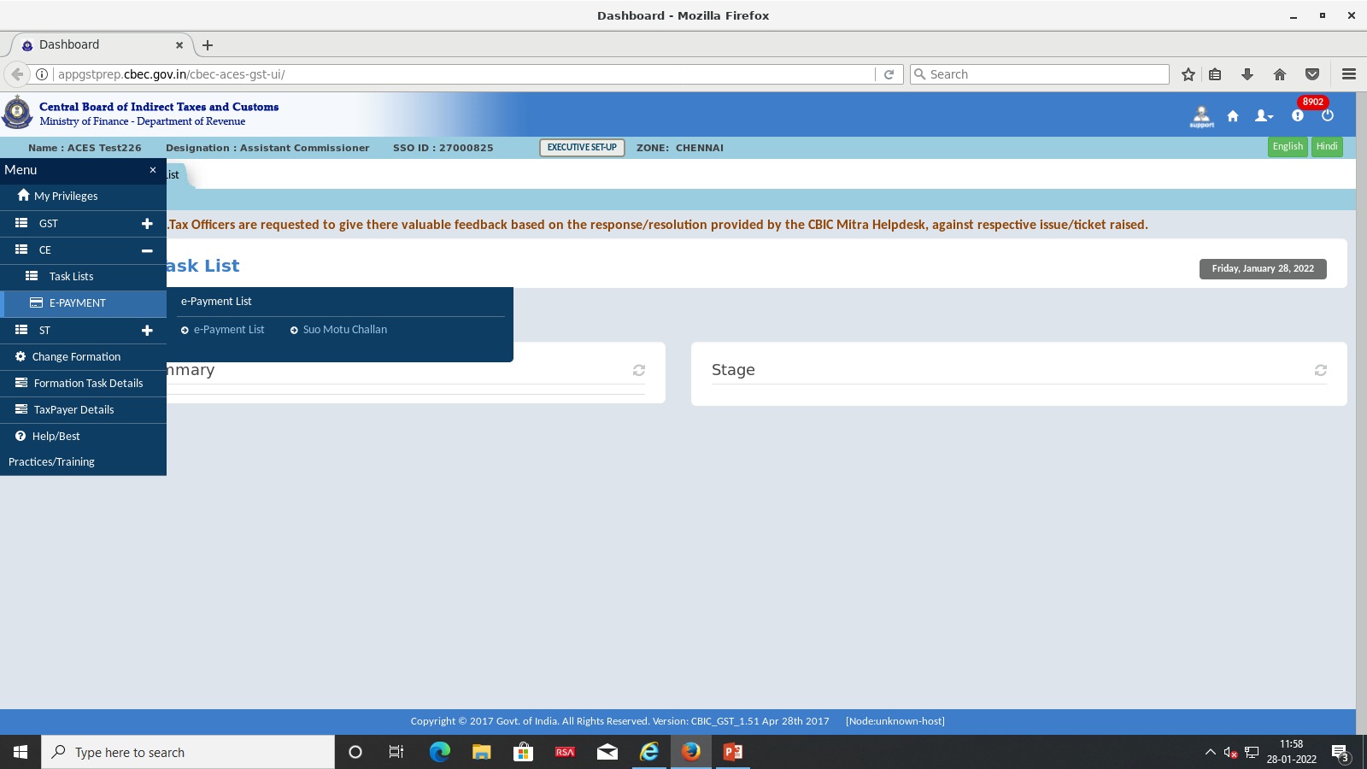

Step 2: “Details of Tax Payer” screen is now enabled, which will show the following fields
- Taxpayer Category: Assessee/ Non-Assessee
- Taxpayer Type: Central Excise/ Service Tax
- Registration Number: Blank Text box
- Create and Clear options:
Tax Officer can select Taxpayer Category, Taxpayer Type from drop down menu, enters Registration Number and clicks “Create” option.
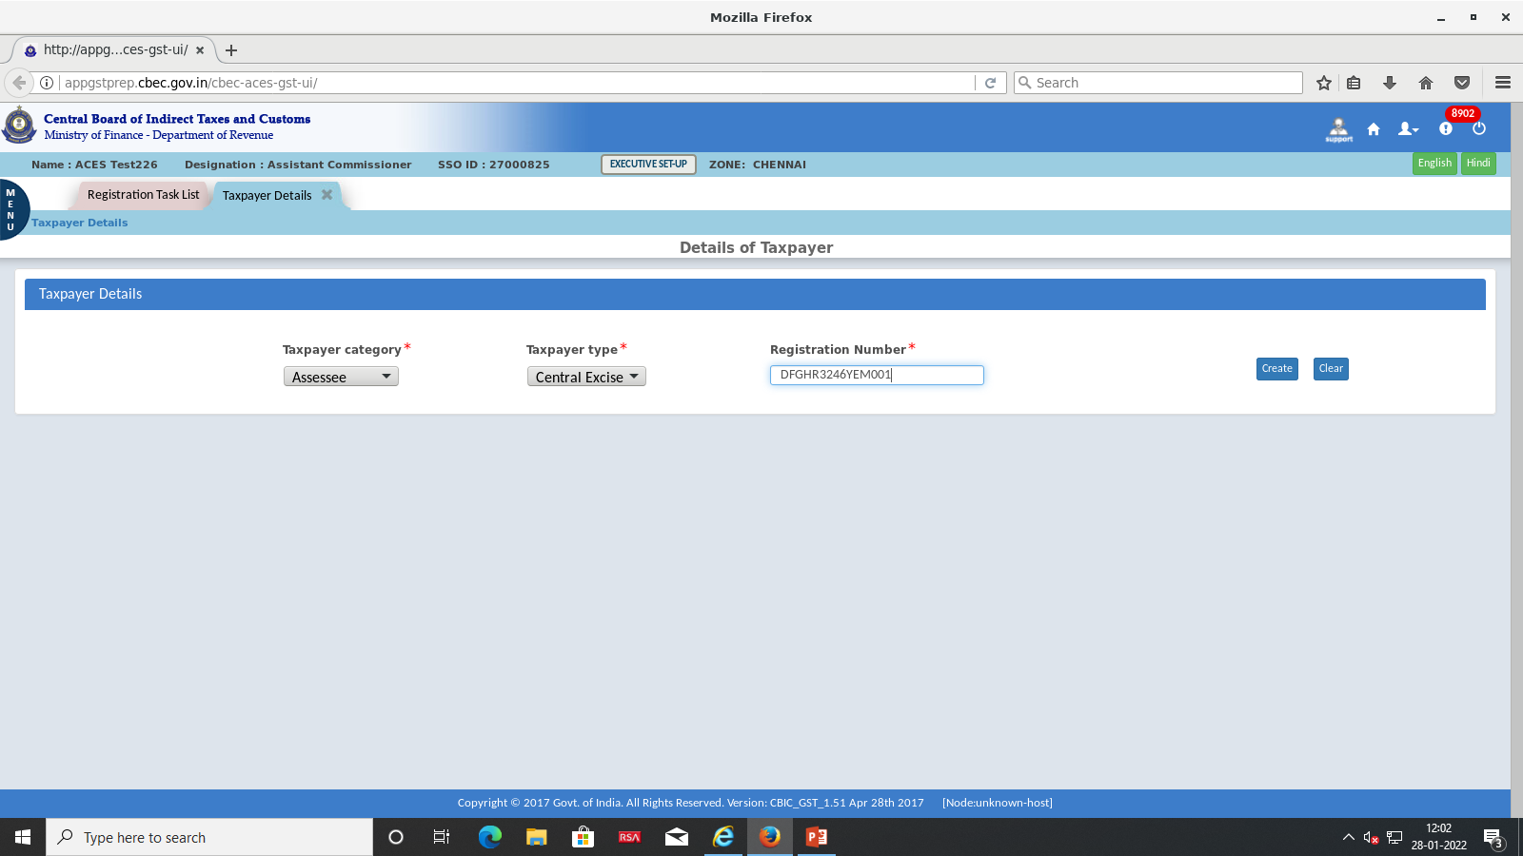

Step 3: System displays “Create Suo Motu Challan” screen with two sub-menus namely “Taxpayer Details” and “Agency Details”.
Under the sub menu “Taxpayer Details”, Registration Number, email address, Mobile Number, Assessee Name, Address and “CDR details” of Taxpayerare displayed. ”Duty details”are enabled with option to select “Accounting Codes”
Tax Officer clicks “Select Accounting Code for Central Excise (or) Service Tax” link depending upon Taxpayer Type selected.System displays pop-up of Accounting Codes based on the Registration Type. If Taxpayer is Central Excise Registered, then Central Excise Accounting codes will be displayed, else Service Tax Accounting codes will be displayed. Tax Officer can select max of 6 Accounting Codes in the pop-up and click “Submit”.
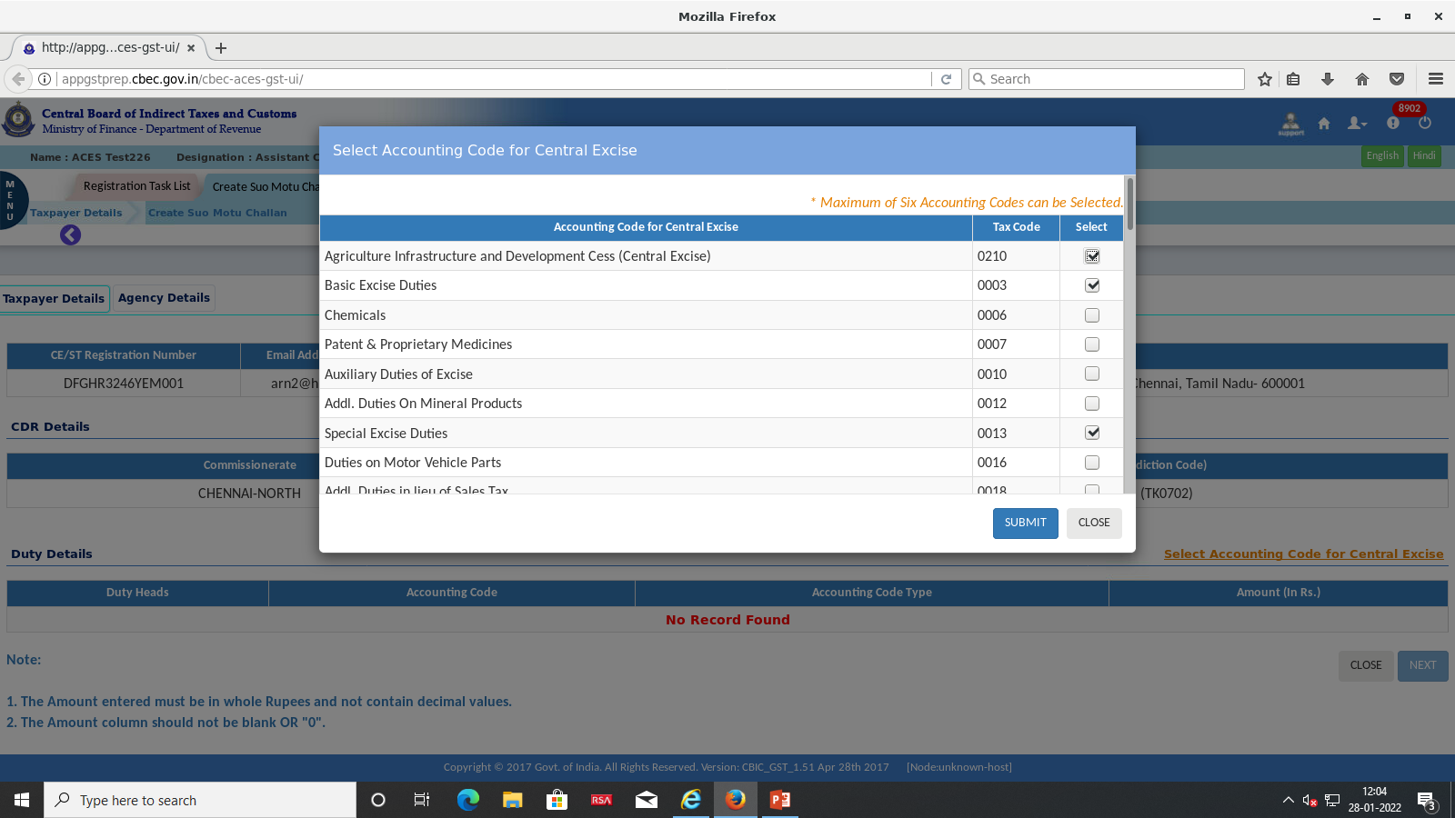
Step 4: System displays the selected accounting codes in the Duty details section. Tax Officer can enter amount corresponding to each account head and total is auto calculated at the bottom of the screen. Once amounts against all accounting codes are entered Tax Officer selects “Next” button
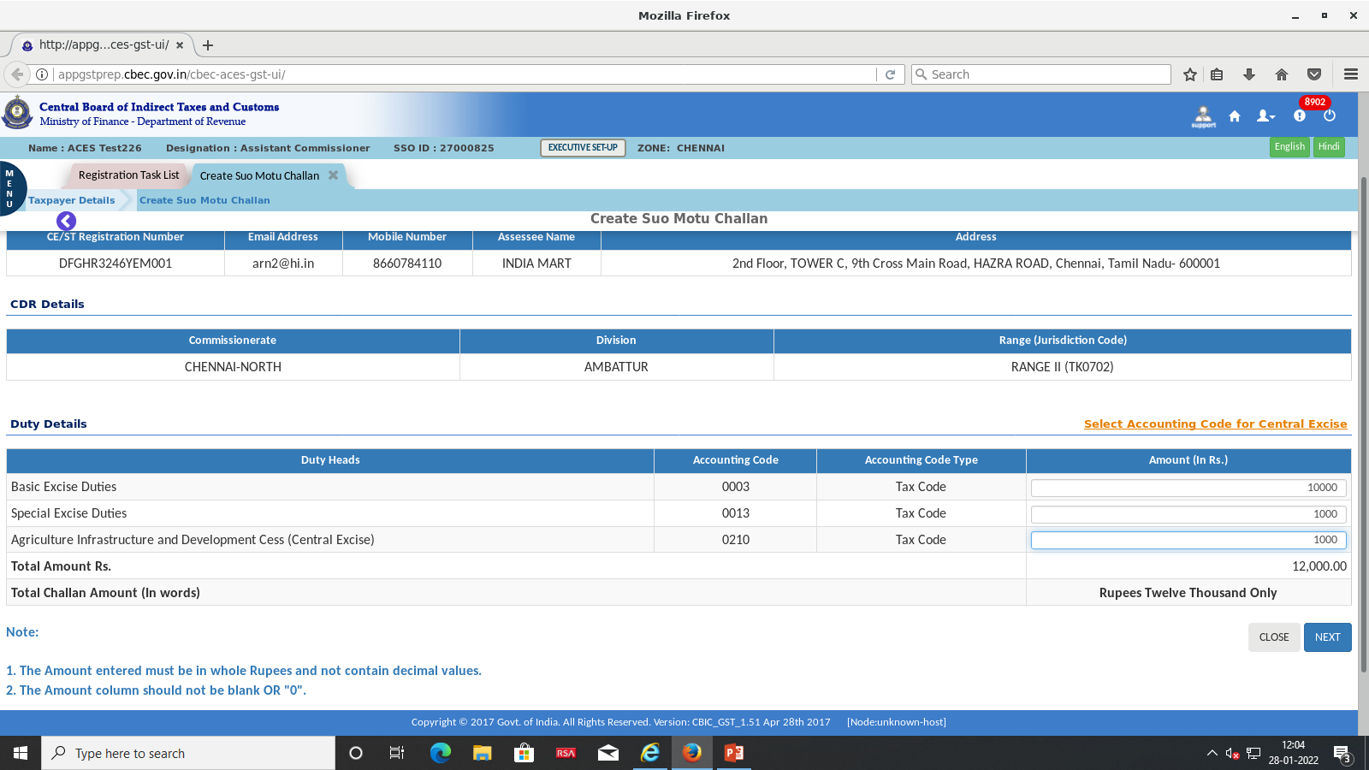
Step 5: Underthe sub menu “Agency Details” ,Tax Officer can enter the details of Agency Name, Instrument Type from the drop down menu, Instrument Ref. Number, Date and Amount (It should be equal to the “Total Amount” mentioned under the tab “Duty Details”).
In the Agency Name, Tax officer can enter the details of the Bank, Financial Institution, IFSC, Branch Address etc.,
In the “Remarks” Section, Tax officer can enter the particulars of the Authority/Departmental entity carrying out the recovery activity, office address and file reference, case details in brief and such relevant details.
In Document details, Maximum of 4 supporting documentsupto 4MB can be uploaded (maximum 1 MB per document) - File format allowed: pdf (or) jpeg. Tax officer can then click “Next” button.
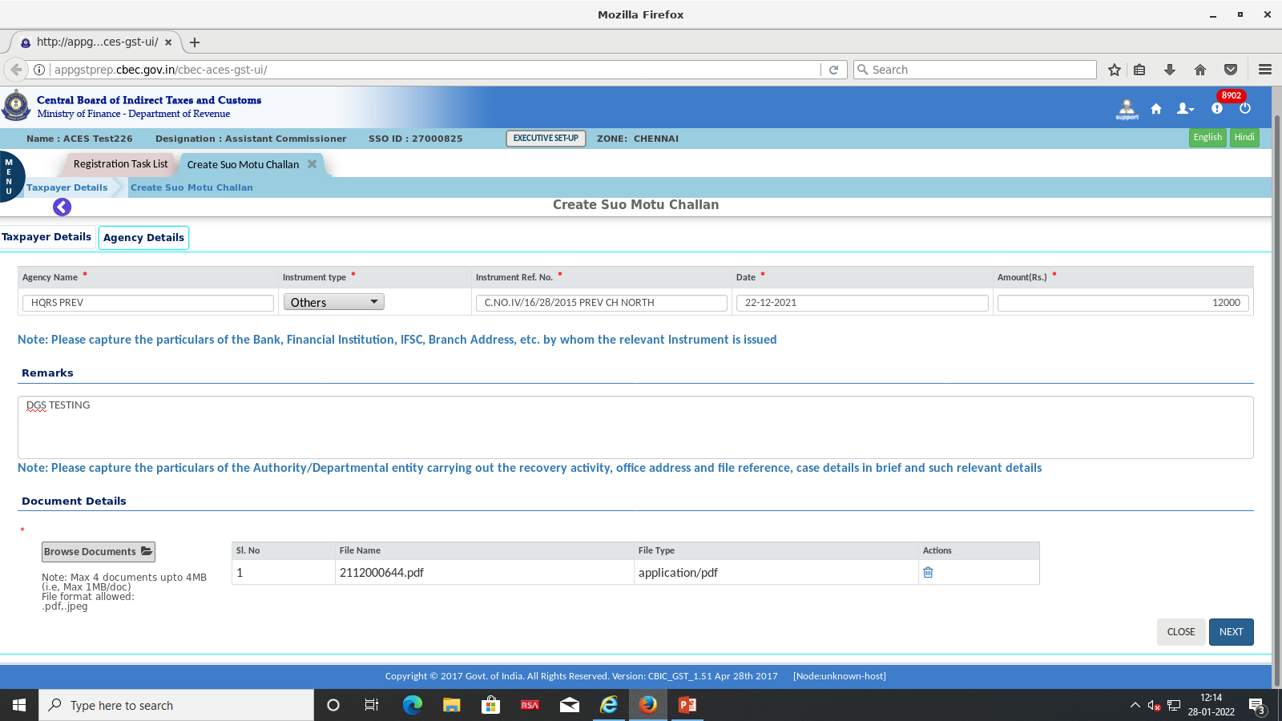

Step 6: System displays the entered details enabled with “Edit” and “Generate Challan” options. Tax Officer can edit or click “Generate Challan” link for generating the challan.
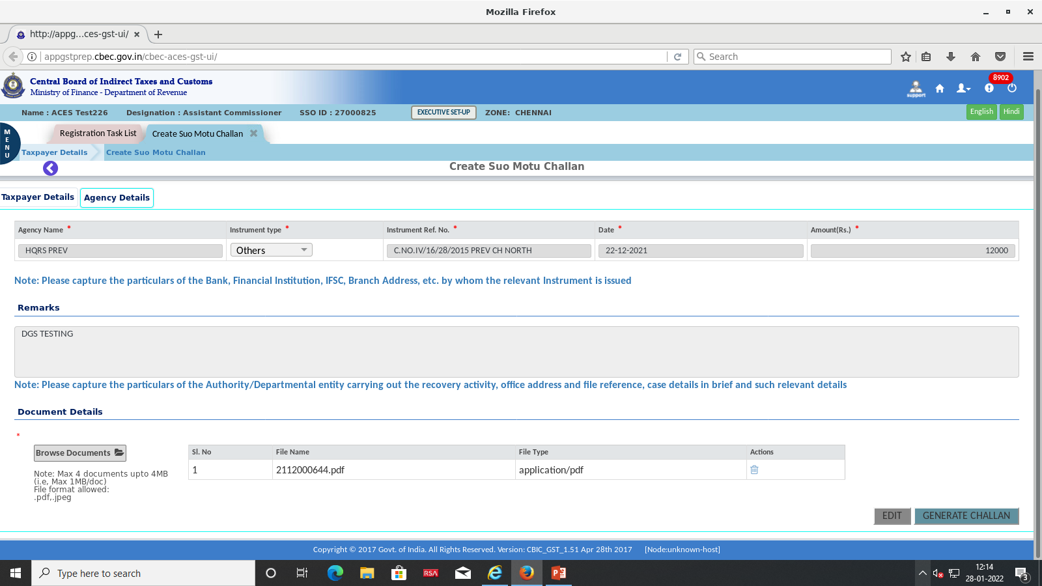
Step 7: System processes the Suo Motu challan details and displays pop-up message 1). “Please wait Challan generation will complete in …. Secs”,thereafter2).“Challan generated successfully with CTIN: xxxxxxx”and a new button 3). “Make Payment” will be displayed. In case Tax officer is not ready to initiate the payment now, they can do so later, by clicking the “MAKE PAYMENT” button available under Menu>CE or ST >E-payment>E-payment List >View CE/ST payments”.
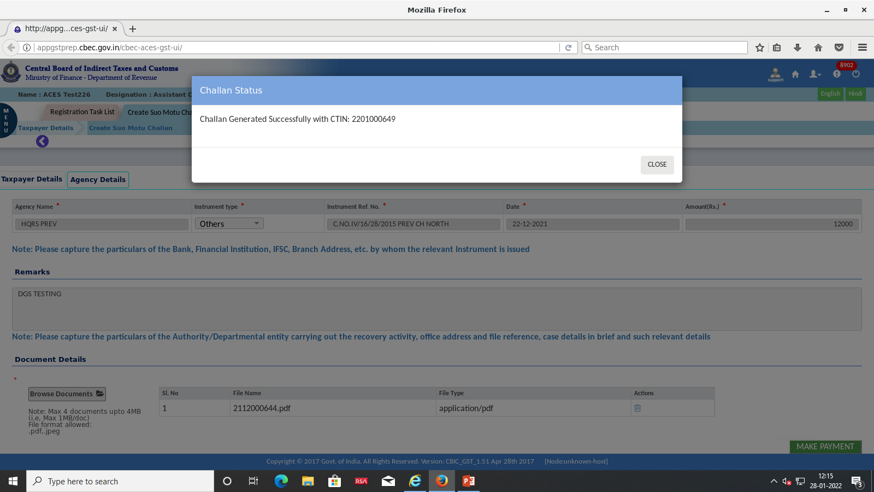
Step 8:On click of “Make Payment”, Tax officer will be re-directed to ICEGATE portal where Tax officer has to select “Duty Type” “Document Type” and “Location” details from drop down menu. Registration Number should be entered in “Identification Number”Tab. Tax Officer will submit after entering the CAPTCHA.
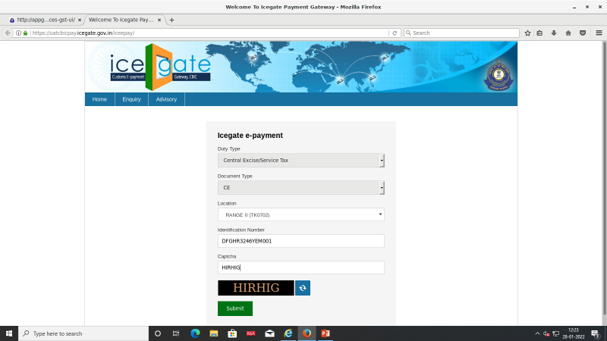
Step 9: The list of Unpaid challans of Taxofficer will be displayed in ICEGATE portal in next screen. Tax officer can select the unpaid challan in the check box and click “Confirm challan” button.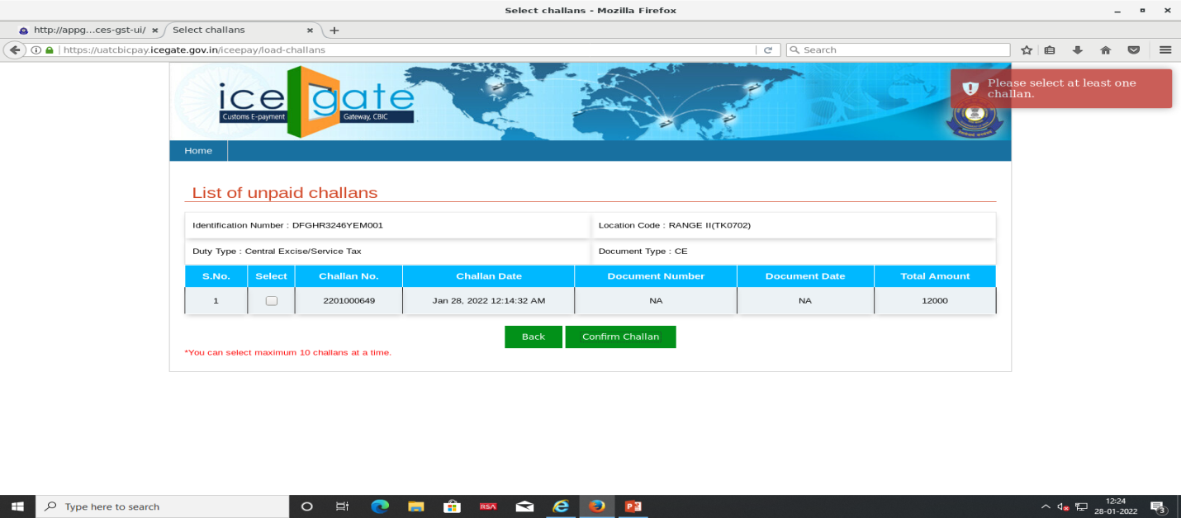
Step 10: Once Tax officer select “Confirm Challan” button, the next screen “List of Selected Challans” appears and the Tax officer has to click the button‘Pay Now’
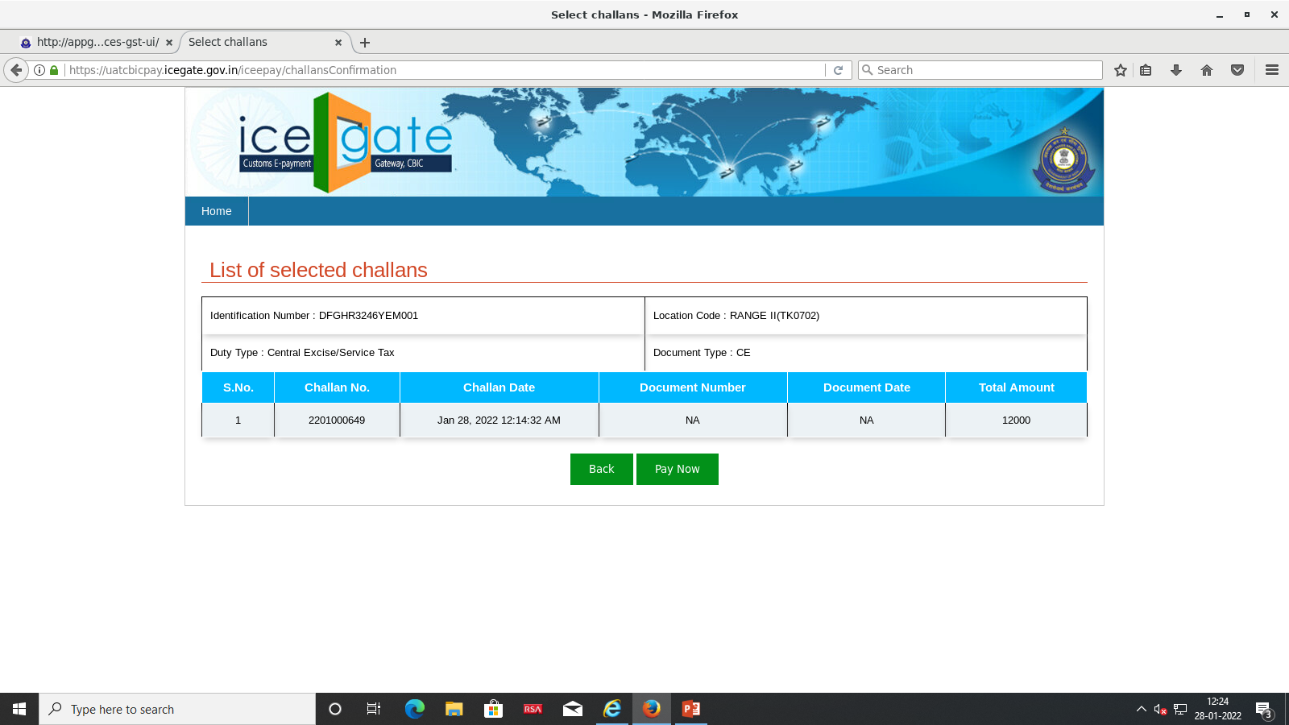
Step 11: In the Next screen ”Payment options” Tax officer has to select the option either “NEFT” or “RTGS”only and click “Generate mandate Form”.
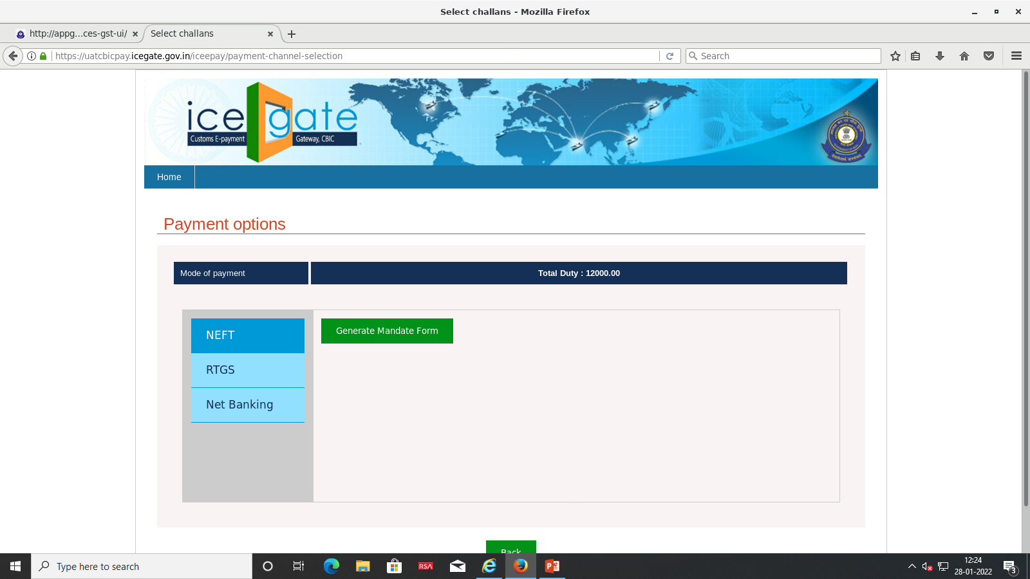
Step 12: A Mandate Form will be generated. Tax Officer will be able to take the print of the Mandate Form and use it to make the payment in the designated bank to credit the amount in the Govt account.
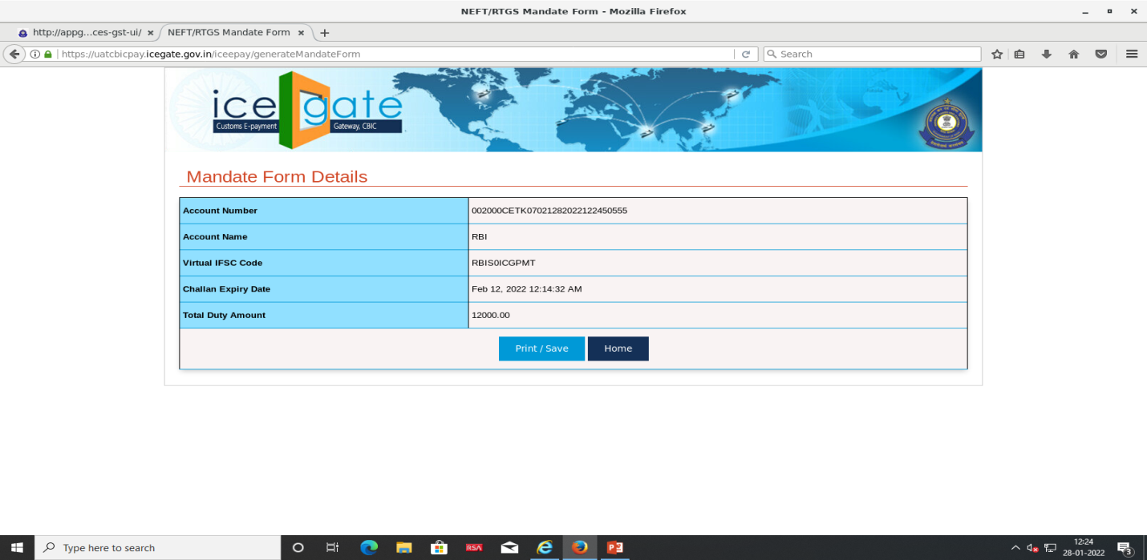

Procedure for Payment in Person at Branch of designated Bank
Taxofficer presents the Mandate challan at the designated Bank branch along with the “Instrument” (cheque/DD etc.) to make the payment.
- Bank will initiate the payment and collect the amount and deposit in the government account.
- Bank will send NEFT/RTGS information to RBI
- RBI will update the payment information and send the details to ICEGATE.
- ICEGATE will send the transaction details to ACES GST Portal.

Step 13: After payment, Tax officer can view the payment details under Menu> CE or ST >E-payment>E-payment List >View CE/ST paymentsby selecting the CTIN.The screen page “Details of Tax payer Summary View” will display all the details under the TAB” Duty details”, “Payment Details”, Agency Details” and “Officer details”. To view/download the challan, Tax officer can click the button “Download challan details”
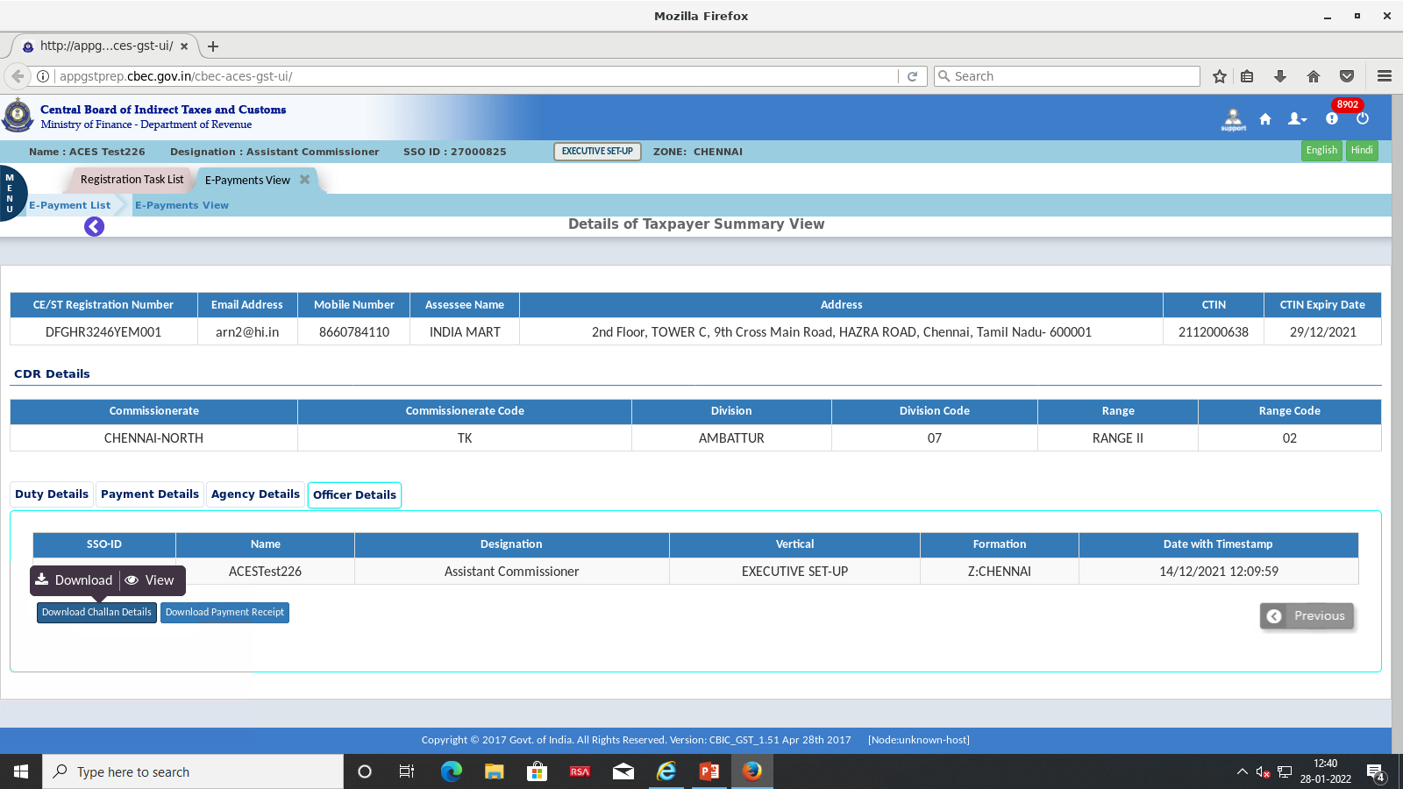
Step 14: A new functionality of download of “E-Receipt” for payments of CE/ST made under ICEGATE e-Payment gateway has been introduced now for both tax payers and Tax officers. Tax Officer can view/download the “E-receipt” by clicking the button “Download Payment Receipt” .
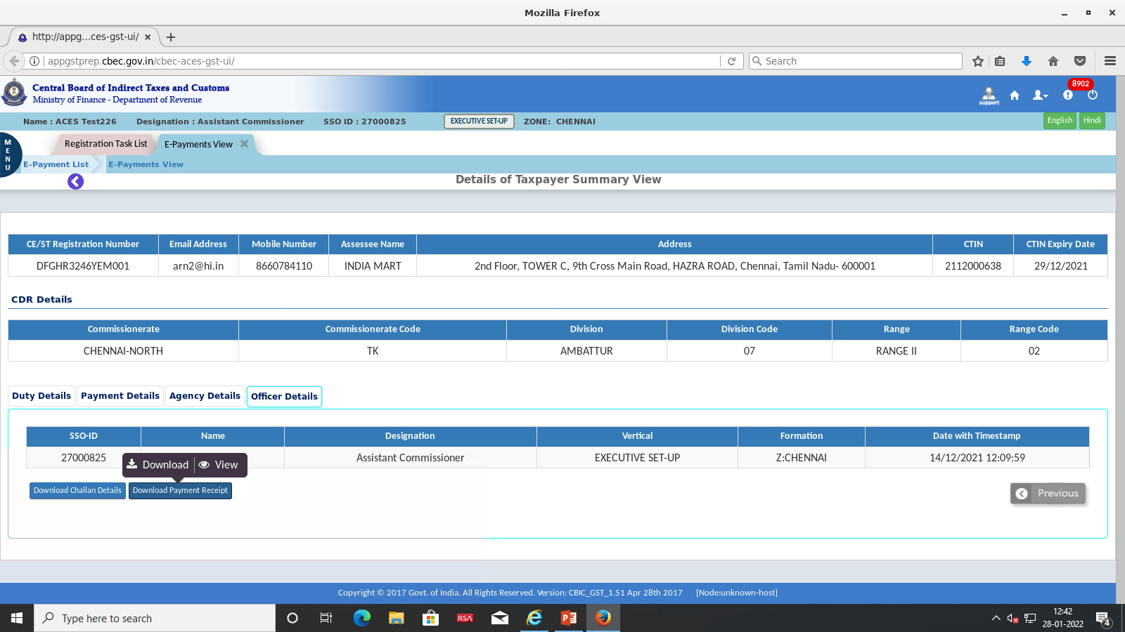
Step 15: The downloaded e-receipt as approved by Pr CCA is given below.
